Determining Amount of Aspirin in Aspirin Tablets by Spectroscopy
Troy University Chemistry Faculty
Licensed under a Creative Commons Attribution-ShareAlike 4.0 International License.

Introduction
The object of this lab is to determine how much aspirin is in aspirin tablets. The active ingredient in aspirin is acetylsalicylic acid, abbreviated in the lab as ASA. Its structure is shown below. Originally, a compound found in bark from willow trees was found to reduce fevers. Since the willow family is called the salix family, the compound with analgesic properties was called salicylic acid. This substance is very hard on the stomach. It was found that adding an “acetyl group”, —COCH₃, reduced the stomach problems. The substance with the acetyl group on it is called acetylsalicylic acid.
Eq (1)
acetylsalicylic acid, ASA salicylic acid
The amount of ASA in aspirin tablets is less than 100%, because the tablets contain binders and, perhaps, fillers. The amount of ASA present will be determined by reacting the ASA with iron(III) ion, which makes the solution dark red, and measuring the intensity of the red color.
The iron(III) ion reacts with the salicylate ion, but not with ASA, so the acetyl group has to be removed from the ASA. This is done by heating the ASA in solution with sodium hydroxide, as shown in equation 1, above. Next, Fe³⁺ is added, which combines with the salicylate ion to form a “complex” (a combination of a Lewis acid and Lewis base), equation 2. This complex is dark red in solution.
Eq (2)
Dark red complex
The intensity of the dark red color is measured using a spectrometer, Figure 1. The container holding the sample is called a cuvette. It usually has a square cross-section.
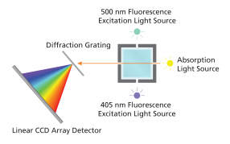
Figure 1. The light path in the spectrometer.
In the spectrometer light goes through the cuvette (the bluish square), the solution in which absorbs some of the light. The light then goes through a “diffraction grating”, which, like a prism, spreads white light out into its colors. The intensity of each color is measured with a detector (the “array detector” measures the intensity of all the colors at one time). For light having a wavelength of, say, 530 nm, the intensity of light entering the sample is called I₀ (It is actually measured with the cuvette having just a blank sample in it). The intensity of light leaving the sample is called I. The amount of light transmitted by the sample is defined as $T=\frac{I}{I_{0}}$, where T is the transmittance. However, the quantity that is directly proportional to concentration is something called the absorbance, A, which is given by A = –log T$=-log⁡(\frac{I}{I_{0}})$, that is, the negative logarithm of T. Absorbance does not have any units. The spectrometer used in the lab automatically calculates the absorbance.
This relation between absorbance and concentration is given by Beer’s Law:
A = ϵbc, Eq (3)
where c is the concentration in mol/L, and b is the path length of the light through the sample, which is the thickness of the cuvette; the path length is usually 1 cm. The ϵ is the molar absorptivity; it gives the relation between absorbance and concentration. The value of ε depends on the substance being analyzed and on the wavelength. The units of ε are molar^{–1} cm^{–1}, which cancels out the units of b and c. According to Beer’s Law, a plot of absorbance vs. concentration is a straight line. The equation for a straight line is y = mx + b, where m is the slope and b is the y-intercept. Equation 3 doesn’t have any “+ b” part, which means that the y-intercept is expected to be zero. Figure 2 shows several data points plotted on a graph. The best-fit straight line is also shown, along with the equation of the line. According to that equation, the slope of the line is 300, which, according to Beer’s Law, is εb, and, since b has a value of 1 cm, ε must be 300. So, from this plot, the molar absorptivity is found from the slope to be 300.

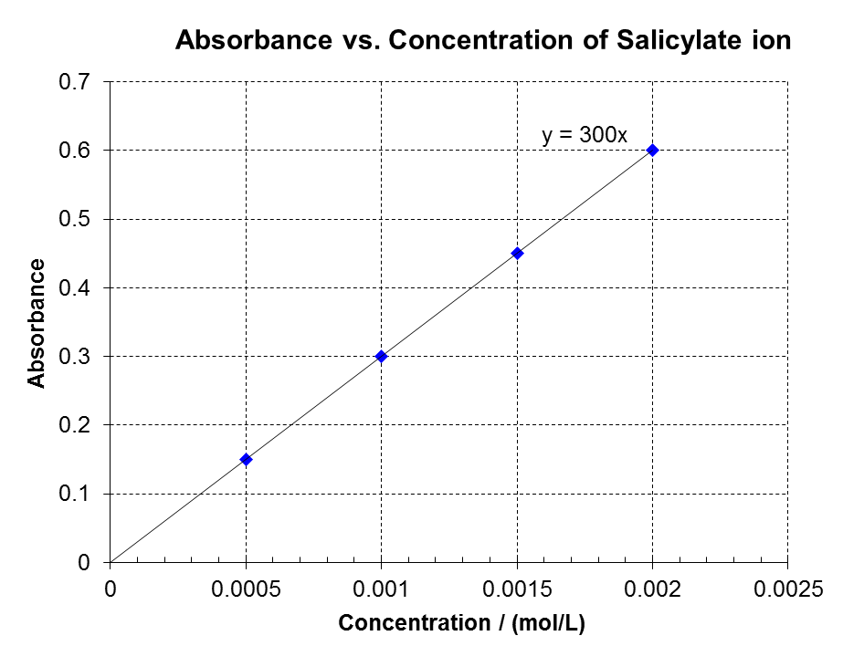
Procedure
Caution! This lab uses sodium hydroxide, which can cause severe eye damage. Also, hydrochloric acid is present in the iron chloride solution. Do not remove your safety goggles while in the lab.
Figure 2. Beer's Law plot.

Part 1, Prepare a Calibration Plot
Label a 400 mL beaker “Waste”.

Prepare a Stock Solution of Salicylic Acid
A stock solution is a concentrated solution from which dilute solutions are prepared. The stock solution of salicylic acid is made from acetylsalicylic acid by heating the acetylsalicylic acid, ASA, in base (eq 1). To do this, weigh about 0.4 grams of ASA on weighing paper. Record the actual mass used on the data sheet to the nearest milligram, 0.001 g. Transfer this solid to a 125 mL Erlenmeyer flask. Using a graduated cylinder, transfer about 10 mL of 1.0 M NaOH into the Erlenmeyer flask. Heat the contents of this flask to boiling on a hot plate.
Transfer the contents of the Erlenmeyer flask to a 250 mL volumetric flask using a plastic funnel. Dilute to the mark with deionized water. Stopper the flask. Mix the contents of the flask by inverting the flask three times, swirling it each time it is inverted. This is the stock solution from which the other solutions are made. Label this solution “stock”.
Every time a volumetric flask is filled, it must be mixed by inverting and swirling as just described. Failure to mix the contents of a volumetric flask will dramatically decrease the accuracy of your results.
Calculate the concentration of this stock solution of salicylic acid in moles per liter. The molar mass of ASA is 180.2 g/mol; the number of moles of salicylic acid present after heating with base is equal to the number of moles of ASA initially present. So, to get molarity, determine how many moles of ASA were weighed out, and divide by the final volume of the solution. Record this molarity on the data sheet.

Prepare Diluted Solutions of Salicylic Acid
Five diluted solutions will be prepared from the stock solution. These solutions will also contain iron(III), KCl, and HCl. The iron(III), of course, forms a complex with the salicylate, making these solutions dark red. The more salicylate ion used to make the solution, the redder the solution will be. The KCl is a source of chloride ion, which helps to keep the iron(III) in solution; the HCl also helps to keep the iron(III) in solution by reducing the concentration of OH– so that rust (Fe₂O₃) does not precipitate.
These five diluted solutions are prepared by diluting 5.00, 4.00, 3.00, 2.00, and 1.00 mL of the stock solution in a 100 mL volumetric flask. To start, obtain a 5 mL graduated pipet, a pipet pump, a 100 mL volumetric flask with stopper, and 5 125 mL Erlenmeyer flasks (to store the solutions in). Rinse the 5 mL graduated pipet with about 1 mL of the stock solution to remove whatever was in it previously. (The instructor will show you the proper technique for using a pipet.) Rinse the 100 mL volumetric flask with a few mL of deionized water. Using the 5 mL pipet, transfer 5.00 mL of the stock solution to the clean 100 mL volumetric flask.

Fill the flask using the solution that is labeled 0.02 M FeCl₃–KCl–HCl. (This is the yellow solution stored on the bench top in a large plastic container.) To do this, fill a 150 mL beaker with a little over 100 mL of the yellow iron solution and fill the flask up first to just the base of the neck (a small funnel may be used if desired). Then, use a disposable pipet to fill the flask up to the mark around its neck.
If you try to fill a volumetric flask to the mark using the spigot on the carboy, you are apt to overfill it. It is a lot easier to fill the beaker first, and use the beaker to fill the volumetric flask. Also, when filling volumetric flasks, it is a good practice to add the last few drops using a pipet or water bottle.
Stopper the flask and mix, as described previously. Store this solution by transferring the contents to one of the Erlenmeyer flasks; label that flask “A” using a piece of labeling tape. Repeat this procedure using 4.00, 3.00, 2.00, and 1.00 mL of solution, labeling the Erlenmeyer flasks “B”, “C”, “D”, and “E”, respectively. Check that the color decreases as the amount of salicylate ion added decreases. If the color does not decrease, something is wrong with the solutions.
Calculate the concentrations of salicylate ion in these solutions. This is done using the dilution equation:
M_{concentrated}V_{concentrated} = M_{dilute}V_{dilute}. Eq (4)
In this equation the initial molarity is the concentration of the stock solution. V_{concentrated} is how much was taken, and V_{dilute} is what it was diluted to. Record these concentrations on the data sheet. (Note: these concentrations will be used in the next part, so you might as well calculate them now.)

Start the software (Logger Pro)
- Connect the SpectroVis Plus to a USB port on the computer.
- Double click the Logger Pro 3 icon on the desktop.

Calibrate SpectroVis Plus
The spectrometer is calibrated by having it measure how much light goes through the solution in the cuvette when no substance to analyze is present. A solution containing everything but the substance being analyzed is called a blank. In this lab, the blank is the yellowish iron-KCl-HCl solution.
- Choose Experiment Calibrate Spectrometer 1 from the Experiment menu. Wait until the system finishes warming up (90 seconds).
- Meanwhile, fill a cuvette about ¾ full with the blank solution. Wipe the smooth surface of the cuvette with a tissue paper (finger prints block the light). Place the cuvette in the cuvette holder as shown, with the light going through the clear windows (the light goes through the cuvette from the white lamp symbol to the white arrowhead), and the “ribbed” windows are on the sides.
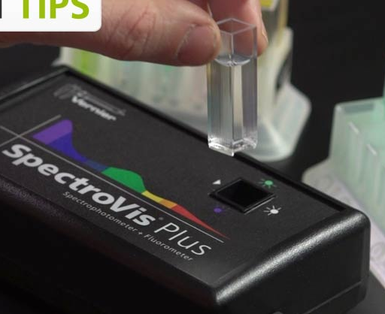
ribbed
clear
Figure 3. A cuvette being inserted into the spectrometer.
- Click “Finish calibration” in the dialog box to complete the calibration Wait until it finishes, then click OK.
- Discard the blank solution from the cuvette and rinse it with distilled water. Save the cuvette for the next steps.

Determine the Maximum Wavelength & Set the Data Collection Mode
- Rinse the blank cuvette twice with small amounts of a standard solution (the most concentrated—darkest—ASA solution). Then, fill the cuvette ¾ full with that solution and place it in the spectrophotometer.
- Set up the data collection mode by clicking the Configure Spectrometer button, . Choose “absorbance vs. concentration” as the Collection Mode. The wavelength of maximum absorbance, λ_{max}, will be selected (it will be the wavelength with a checkmark next to it). It should be around 530 nm. Record this wavelength on the data sheet, where it says λ_{max}. Click OK.

Collect Data (Beer’s Law Plot)
- At this point the cuvette should have been rinsed twice with the solution to be tested, and should be about ¾ full of that solution. The cuvette should have been wiped with a tissue and should be in the cuvette holder of the SpectroVis Plus, oriented so the light isn’t going through the ribbed sides.
- Click the button, wait a few seconds for the absorbance of the solution (shown in the box under the data) to somewhat stabilize (our spectrometers tend to have noise that never completely stops), then click “Keep”. (Don’t click Stop.)
You can tell if things are not working right. If each data point has a different shape, then “Stop” was clicked between readings, and the data will have to be re-recorded.
A box appears; enter the concentration of the sample (the format for entering numbers is “1.23e-4”, but use your own values) and click OK. A point will appear in the Absorbance vs Concentration plot. Record the absorbance of this sample in the data sheet. Expand the graph by clicking on the “Autoscale Graph” icon, . If the absorbance is outside the range of 0.5 – 1.2, then the solutions have not been prepared properly.
- Here is an easy check to make sure the instrument is properly set up: check that the blank still has an absorbance of nearly zero. To do this, fill the cuvette with the blank solution and put the cuvette in the spectrometer. Don’t click any buttons on the software; just observe what the absorbance is. If it isn’t very close to zero, then go back to step 3 and start over (you can click the “skip the warm up” button when starting over). If the blank reading is close to zero, then continue with the next step. (Checking the blank does not need to be done after each sample.)
- Repeat the above steps for each of the remaining samples. When finished, click “Stop” to end data collection. (Don’t dispose of the samples, yet, in case something is wrong and they need to be re-measured.)
- Click Analyze Linear Fit to see the best fit line equation for the standard solutions. Record the slope of this line on the data sheet. Recall that the equation for a straight line is y = mx + b, where m is the slope. If the y-intercept, b, of your data is a long ways from zero, then something was done wrong in the process. Record the slope, y-intercept, correlation coefficient (R²), and molar absorptivity in the data sheet (see the paragraph before the procedure for instructions on how to obtain this last value). Don’t close the software!
- Ask the instructor to approve the data.

Part 2, Analyze Aspirin Tablets

Prepare Aspirin Tablet Samples for Analysis
Once a Beer’s Law plot is made you can use the plot to determine the concentration of the unknown. (Don’t close the software!) First, though, the aspirin tablet has to be dissolved, and the ASA converted to salicylate ion with base. The tablet will not completely dissolve, because it contains binders to hold it together, and the binder does not dissolve in water.
- Obtain three aspirin tablets, all from the same bottle, which is on the bench at the front of the room. Record the brand name of these tablet on the data sheet. Obtain three 125 mL Erlenmeyer flasks. Label them “1”, “2”, and “3”. Place one of them on the balance, tare the balance, add one of the tablets, and record the mass on the data sheet. Do the same for the other two tablets. To each flask add 10 mL of 1.0 M NaOH. Heat the flasks to boiling, being careful not to lose any of the solution (we are trying to be quantitative here). After the solution boils a short time, it may be removed from the heat.
The following part is done with one sample at a time, because it uses a 250 mL volumetric flask.
- Cool the sample by running tap water over the outside of the flask. Quantitatively transfer the contents of the flask to a 250 mL volumetric flask, as done previously. Also, as done previously, dilute to the mark with water, and thoroughly mix. The contents of the flask will probably be a bit cloudy, due to a binder being present. You may need to let the solids settle to the bottom before continuing.
- Next, use a clean pipet to transfer 5 mL of the above solution from the 250 mL flask to a 100 mL volumetric flask. Dilute to the mark as before, using the 0.02 M FeCl₃–KCl–HCl solution. Mix thoroughly.
- Place this aspirin tablet sample in the cuvette holder. Choose Interpolation Calculator from the Analyze menu. A dialog box will appear, displaying the absorbance and concentration of the unknown. Record these on the data sheet. Click OK.
- Discard the sample in the waste container under the hood.
- Repeat with the second sample and, if time permits, with the third sample.
- Print out the plot.

Calculate Percent ASA in Aspirin Tablet
The aspirin tablet was dissolved in 250 mL of solution. 5 mL of that solution was diluted to 100 mL, and the concentration of that solution was measured. Use the dilution equation, equation (4), to determine the concentration of ASA in the 250 mL container. M_{dilute} is the concentration just recorded from the spectrometer. Calculate and record M_{conc} (“Concentration of aspirin in 250 mL flask”) on the data sheet.
The entire tablet is contained in the 250 mL flask, whose concentration was just calculated. Determine how many moles of ASA are in the flask (since molarity = moles/L, then moles = molarity × L; for L, use 0.250 L). Record this on the data sheet.
Convert the moles to grams using the molar mass of ASA, which is 180.2 g/mol. Record this on the data sheet.
The mass just calculated should be somewhat close to the mass the bottle says is in each tablet. Calculate the percent error by assuming that the bottle value is the true value (we probably can trust the manufacturer, but who knows? Also, there may be a random variation in the amount of ASA in the product.). Percent error is given by
$\%=\frac{\left(experimental value-accepted value\right)}{accepted value} ×100$.
Calculate the percent ASA in the tablet (recall that $percent is \frac{part}{whole}×100$).
Finally, calculate the mean percent ASA in the tablet (mean means average).

